MACH4METAL

metalworking machinery
Transito 21, 6909 DA Babberich, Netherlands
Tel. + 31 (0)316 – 247123
Fax. + 31 (0)316 - 247956
www.mach4metal.com
Bank No : 66.52.13.883
IBAN : NL33 INGB 0665 2138 83
BIC : INGBNL2A
VAT : NL 815393635B01

MAZAK INTEGREX E410 multi tasking

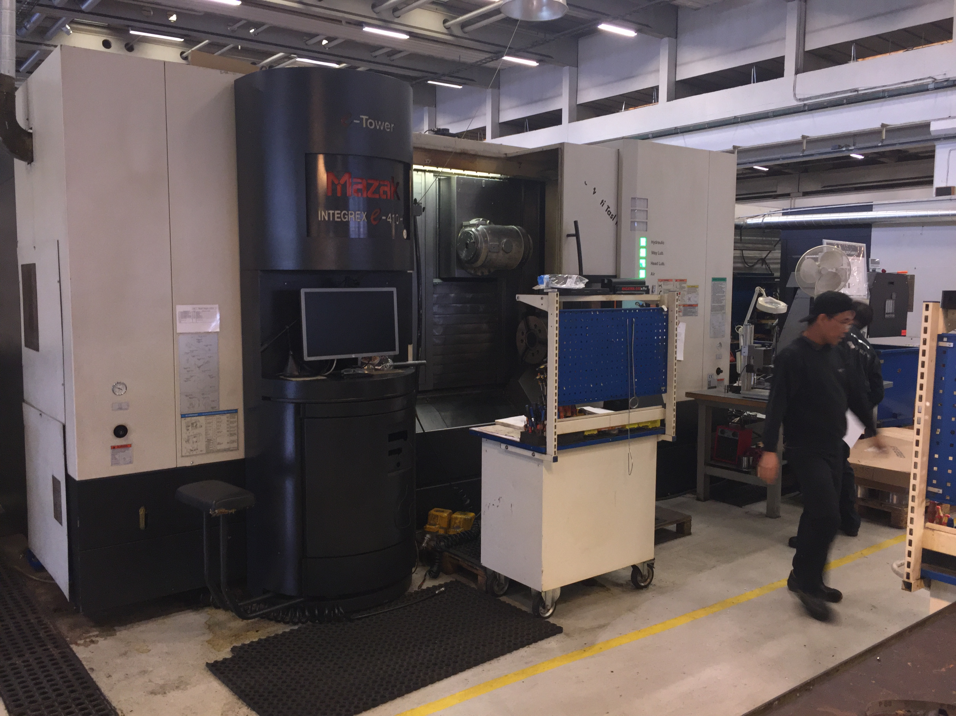
- Make : MAZAK - Yamazaki
- Type : INTEGREX e-410 HS
- Serial NO : 161900
- Age : 2004 – 4450 H

- Machining swing Ø : 610
- DBC turning length : 1.500

- Spindle bore : 88
- X travel : 740
- Y travel : 410
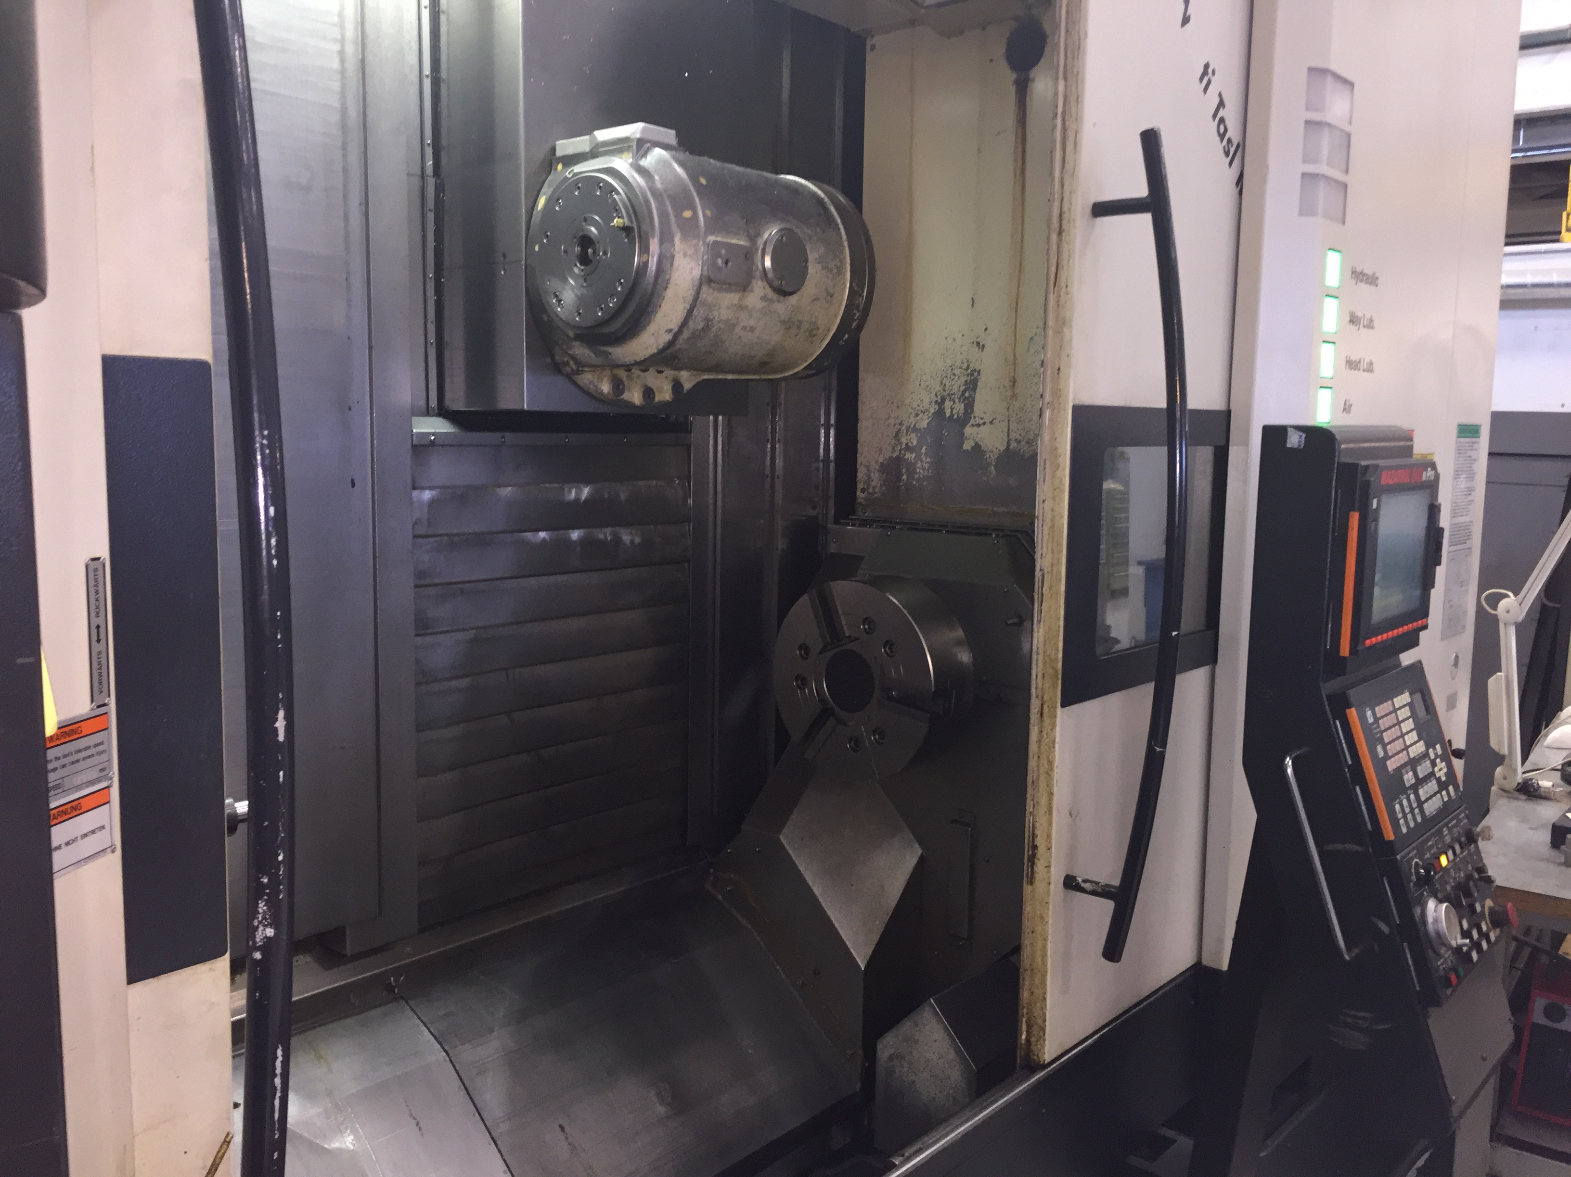
- Z travel : 1.388
- C Axis : 360.000
- W Axis : 1.377
- Spindle speed : 4.000
- Power : 30 kW

- Milling spindle taper : Capto C6
- ATC Chain positions : 40
- Speed range : 12.000
- Motor power : 22 kW
- Rapid feed X/Y/Z/Z2 : 50
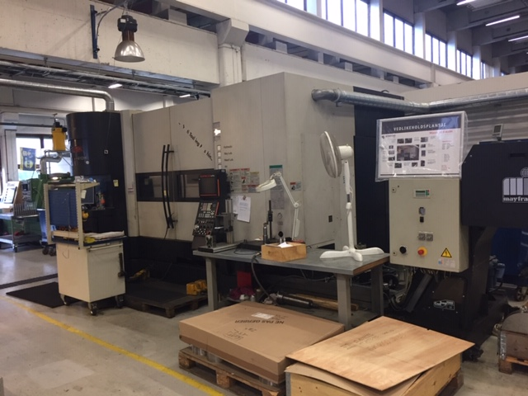
- Sub spindle speeds : 4.000
- Sub spindle power :

- Nexus MATRIX Control
- Chip conveyor
- Coolant system
- Kitagawa chuck

- Dimensions
- Length : 5.070
- Width : 2.920
- Height : 2.980
- Weight : 19.000
Please Note: The above information has been obtained to the best of our ability and belief from, and from the manufacturers where possible. It is given in good faith, but its accuracy can not be guaranteed. Accordingly, it will not form a representation or constitute contractual terms. We advise you to check any vital details

